**Resume**

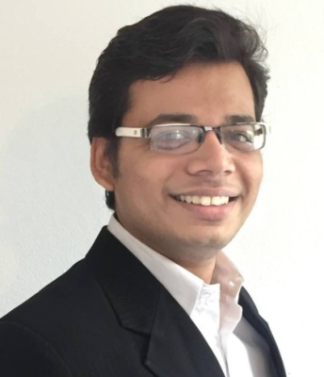**Personal Details**

Name Prithvi Prakashkumar Patel

Address Vogteistraße 5,

88250 Weingarten

Mobile +49(0) 176 40445531

E-Mail prithvi14091996@gmail.com

DOB/POB 14.09.1996 / Ahmedabad, India

Nationality Indian

**Qualification**

**Since 08/2020 M.E., Electrical Engg. and Embedded Systems**

Area of Focus AI, Computer Vision, Automotive Systems

Hochschule Ravensburg Weingarten

Weingarten, 88250 Deutschland

**03/2016 – 08/2020 B.E., Electrical Engg. and IT**

Area of Focus Automation Technology, Networking

Hochschule Ravensburg Weingarten

Weingarten, 88250 Deutschland

**Professional Experience**

**04/2020 - Now** **Master Thesis: Analysis and Evaluation of needs of a new generic and scalable cloud-based OTA update system**

* Design of a new generic and scalable architecture for OTA updates that can be applied to different domains

Soluware GmbH, Ravensburg

**02/2020 – 02/2022** **Working Student –Software Engineer/Developer**

* Projects on Xamarin, .NET Framework: WPF, Web API

Soluware GmbH, Ravensburg

**11/2018 – 10/2020** **Software Development Team Leader (Python)**

* Software-Architecture design, Mars-Rover On-board system

RWU, Weingarten

**Hands-On Projects**

**09/2021 – 02/2022 Restaurant Robot (ROS, Python, Docker)**

* Development of robotic algorithm where the robot picks up the dishes from kitchen as soon as event is triggered, navigates to the table where the order originated and keeps the dishes on the table and return to initial position or state. Developed in Python, ROS, and Docker Containers.

**03/2021 – 08/2021** **Womega E-Commerce Full Stack Web App**

* Fullstack E-Commerce WebApp that allows customers to browse clothing, add to cart and pay with credit/debit cards. Also created an admin portal to maintain products, view analytics of the business and perform business activities. Uses C#, .NET Core for backend, HTML, Bulma CSS and VueJs for frontend and local database.

Github: <https://bit.ly/WomegaWebApp>

**03/2019 – 05/2019** **FPGA Communicator**

* FPGACommunicator is a tool that basically communicates with the FPGA via the UART COM port. This tool was developed in JAVA (Swing) and can be used to read and write hexadecimal values from/to the FPGA.

Github: <https://bit.ly/FPGACommunicator>

**Technical Skills**

**Skills**  C, C++ with graphics and embedded programming,

JAVA – Android Studio, Swing, Linux command line, Git and Gitlab for projects, Meld

C# for Xamarin, WPF und Web API .Net Framework, und .Net Core MVC – MVVM Web Application, C++, Python (ROS), SCRUM,

Cloud architectures, Software architectures, Design Patterns

Software tools Code::Blocks, Netbeans IDE, Eclipse IDE, Design Suite,

Atom IDE, Microsoft Office: Word, Powerpoint, Excel und Access,

Visual Paradigm UML-Werkzeug, Visual Studio., C#, Android Studio, Visual Studio Code

**Languages**

Deutsch Advanced (Niveau B2)  
English Fluent in Writing/Speaking   
Gujarati Mother Tongue

**Hobbies**

Part-time Indie Game Developer

Weingarten, 28.06.2022

Prithvi Patel